  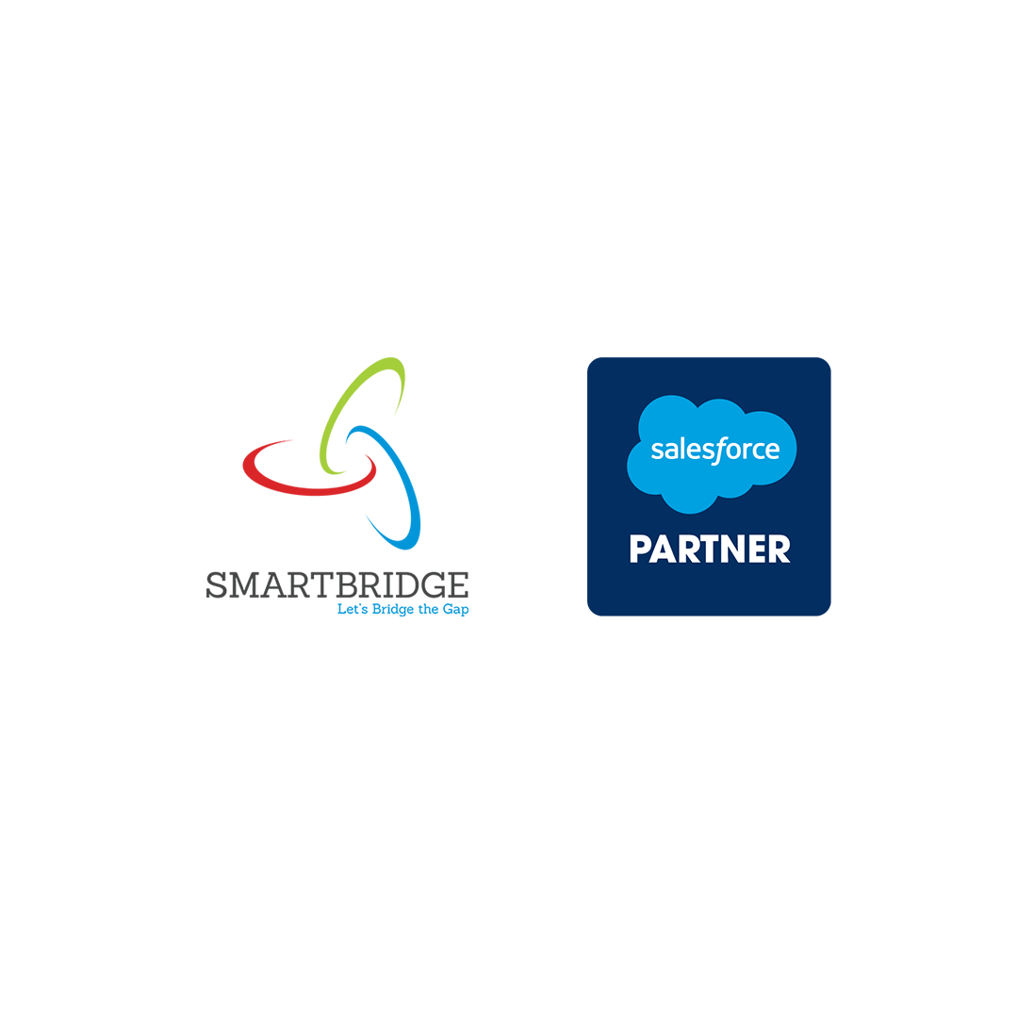

Project Title: ***Creation of an Application for School Management – Admin***

 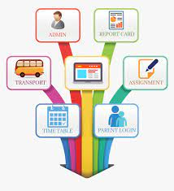

**Presented By**

**Team ID**: **LTVIP2023TMID06078**

**TEAM DETAILS:**

1.ATHUKURI MANI [*208x1a0504@khitguntur.ac.in*]

2.IGUTURI KOWSHIKREDDY [208x1a0525@khitguntur.ac.in]

3.PUTTTA ANJAN [208x1a0579@khitguntur.ac.in]

4.NADAKUDITI AJAY KUMAR [208x1a05f5@khitguntur.ac.in]

5.ARZA RAMDEEPAK SAI [208x1a0549@khitguntur.ac.in]

**Our Trailblazer accounts**

***NAMES* Profile Id’s**

1.ATHUKURI MANI - https://www.salesforce.com/trailblazer/s208x1a0504

2.IGUTURI KOWSHIKREDDY - https://www.salesforce.com/trailblazer/s208x1a0525

3.PUTTTA ANJANI - https://www.salesforce.com/trailblazer/s208x1a0579

4.NADAKUDITI AJAY KUMAR - https://www.salesforce.com/trailblazer/ajayf5

5.ARZA RAMDEEPAK SAI - <https://www.salesforce.com/trailblazer/s208x1a0549>

# INTRODUCTION

**Overview:**

The School Management Application in Salesforce is a cloud-based software solution that can be used to streamline administrative tasks and improve communication in educational institutions. The application can be used to track student attendance, manage student records, create and manage examinations, and generate reports on school performance. It can also be used to facilitate communication between teachers, parents, and students.

**Purpose:**

The application will have the following purposes:

* Automate administrative tasks such as attendance tracking, student records management, and examination management.
* Improve communication between teachers, parents, students, and administrators.
* Provide valuable insights through reports and analytics.
* The application fosters seamless communication between teachers, parents, students, and administrators through announcements and notifications.
* It simplifies attendance tracking, academic performance monitoring, and examination/result management for teachers and administrators.
* The application provides valuable reports and analytics to aid data-driven decision-making for improved school performance and resource management.

# LITERATURE SURVEY

**Existing Problems**:

* Inefficiencies: Manual processes are time-consuming and error-prone. Spreadsheets can be difficult to manage and update, and they can be easily corrupted. Disparate software systems can lead to data silos, which makes it difficult to get a complete picture of a student's academic record.
* **Data inconsistencies:** When data is stored in multiple systems, it is easy for it to become inconsistent. This can lead to inaccurate reports and decisions.
* **Communication gaps:** When there is no central communication platform, it can be difficult for teachers, parents, and administrators to communicate with each other. This can lead to misunderstandings and delays.
* **Increased costs:** Schools may need to hire more staff to handle administrative tasks, or they may need to invest in expensive software.
* **Reduced productivity:** Teachers and administrators may spend a significant amount of time on administrative tasks, which takes away from time they could be spending on teaching and learning.
* **Poor student outcomes:** When students' academic records are inaccurate or incomplete, it can make it difficult for them to get the help they need.
* **Dissatisfied parents and guardians:** Parents and guardians may be frustrated with the lack of communication from the school, or they may be concerned about the security of their child's data.

**Proposed Solution:**

* A comprehensive cloud-based school management application will be developed.
* The application will have an intuitive interface, automation features, and seamless integration.
* It will facilitate efficient attendance tracking, academic management, and communication among teachers, parents, students, and administrators.
* The application will provide valuable insights through analytics and reports, ensuring data-driven decision-making.
* The application will have robust security measures and customization options, allowing schools to enhance overall efficiency and productivity, creating a more streamlined and effective learning environment.

**Key Benefits of Proposed Solution:**

* **Improved efficiency and productivity**: The cloud-based application will allow schools to automate many administrative tasks, freeing up staff time to focus on more important activities.
* **Enhanced communication:** The application will provide a platform for teachers, parents, students, and administrators to communicate with each other easily and effectively.
* **Improved decision-making:** The application will provide valuable insights into student performance and school operations, which can be used to make better decisions.
* **Increased security:** The application will have robust security measures in place to protect student data.
* **Customization:** The application will be customizable to meet the specific needs of each school.

Overall, the proposed solution is a comprehensive and innovative approach to school management. It has the potential to significantly improve the efficiency, productivity, and effectiveness of school operations.

# THEORITICAL ANALYSIS

**Process Diagram:**

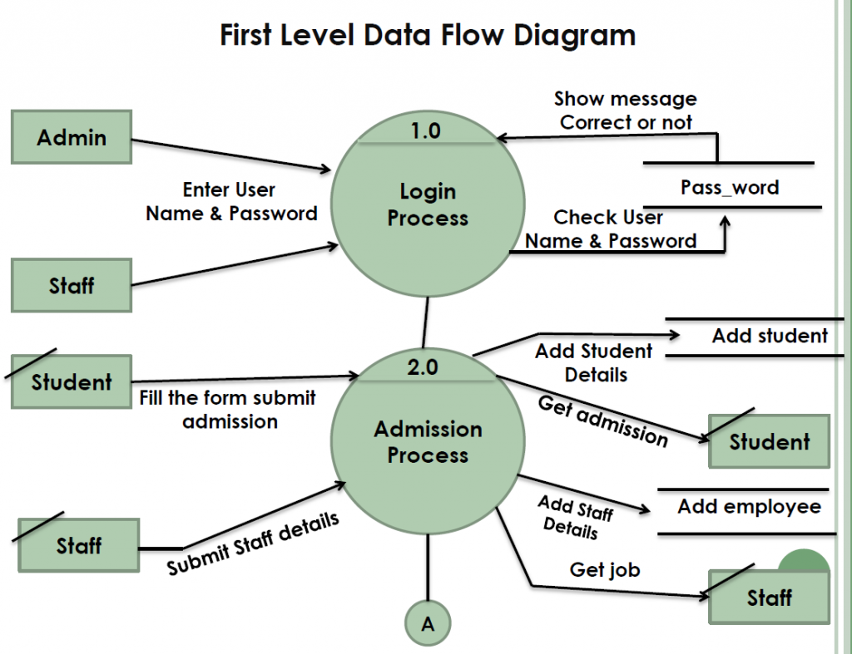

**Hardware and Software Designing:**

The School Management Application will be developed on the Salesforce platform, which is a cloud-based software solution. This means that most of the hardware requirements will be taken care of by Salesforce. However, there are still some essential hardware and general requirements to consider:

* **Hardware requirements:** 
  + The following hardware requirements are essential for running the School Management Application on the Salesforce platform:
    - A computer with a minimum of 4GB of RAM and 20GB of free disk space.
    - A web browser that supports HTML5 and JavaScript.
    - A reliable internet connection.
* **Salesforce platform requirements:** 
  + The following Salesforce platform requirements are essential for running the School Management Application:
    - A Salesforce account.
    - A Salesforce edition that supports the features and functionality required by the application.
    - Salesforce licenses for the users who will be accessing the application.
* **Salesforce limits and allocations:**
  + Salesforce imposes limits on the number of API calls, data storage, and custom objects and fields that can be used by each Salesforce account. These limits must be considered when designing and developing the School Management Application.
* **Security and compliance:**
  + The School Management Application must be designed and developed with security and compliance in mind. This includes protecting student data from unauthorized access, ensuring that the application meets all applicable data privacy regulations, and implementing user authentication to prevent unauthorized access to the application.
* **Customization and development:**
  + The School Management Application can be customized to meet the specific needs of each school. This includes customizing the user interface, adding new features, and integrating with other systems.
* **User training and support:**
  + Users of the School Management Application must be trained on how to use the application effectively. Technical support must also be available to users who need help with the application.

# PROCESS AND RESULTS

**1.Creating Developer Org:**

Creating a developer org in salesforce

1. Go to [developer.salesforce.com](https://developer.salesforce.com/)
2. Click on sign up.
3. On the signup form, enter the following details
4. First name & Last name
5. Email
6. Role – Administrator
7. Company - College Name
8. Country – India
9. Postal Code - pin code

Username- should be a combination of your name and company

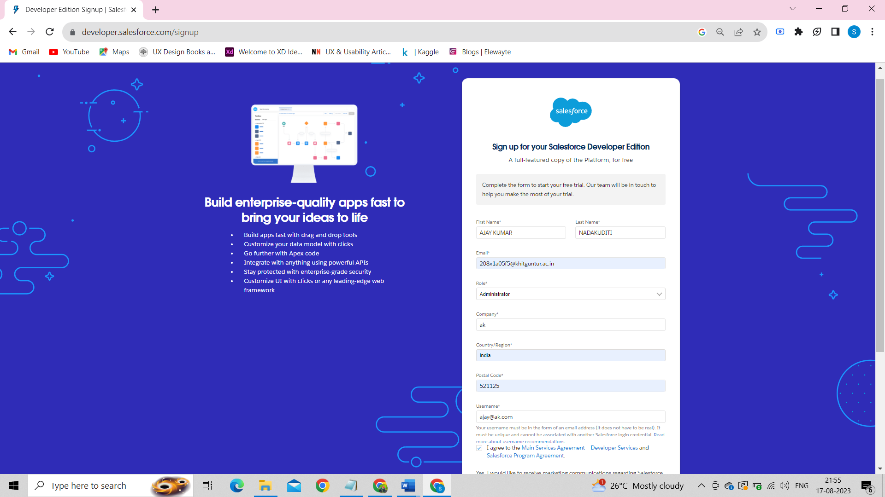

**2.Account Activation:**

We have to verify our email to activate the account. So, click on verify account to activate the Salesforce Account

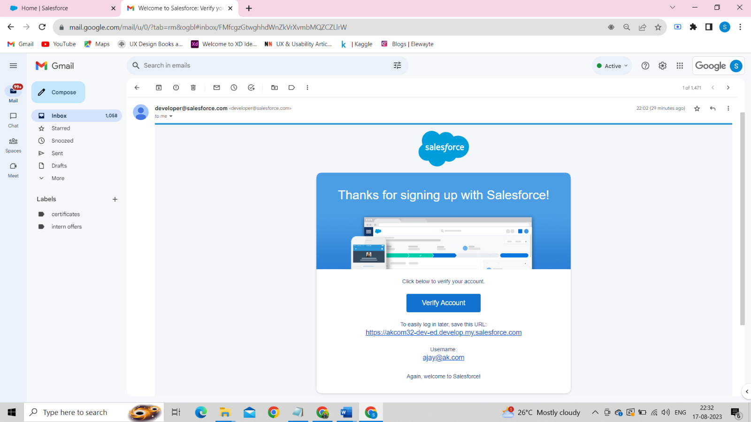

After verifying, it asks to set up the password including a security question like below:

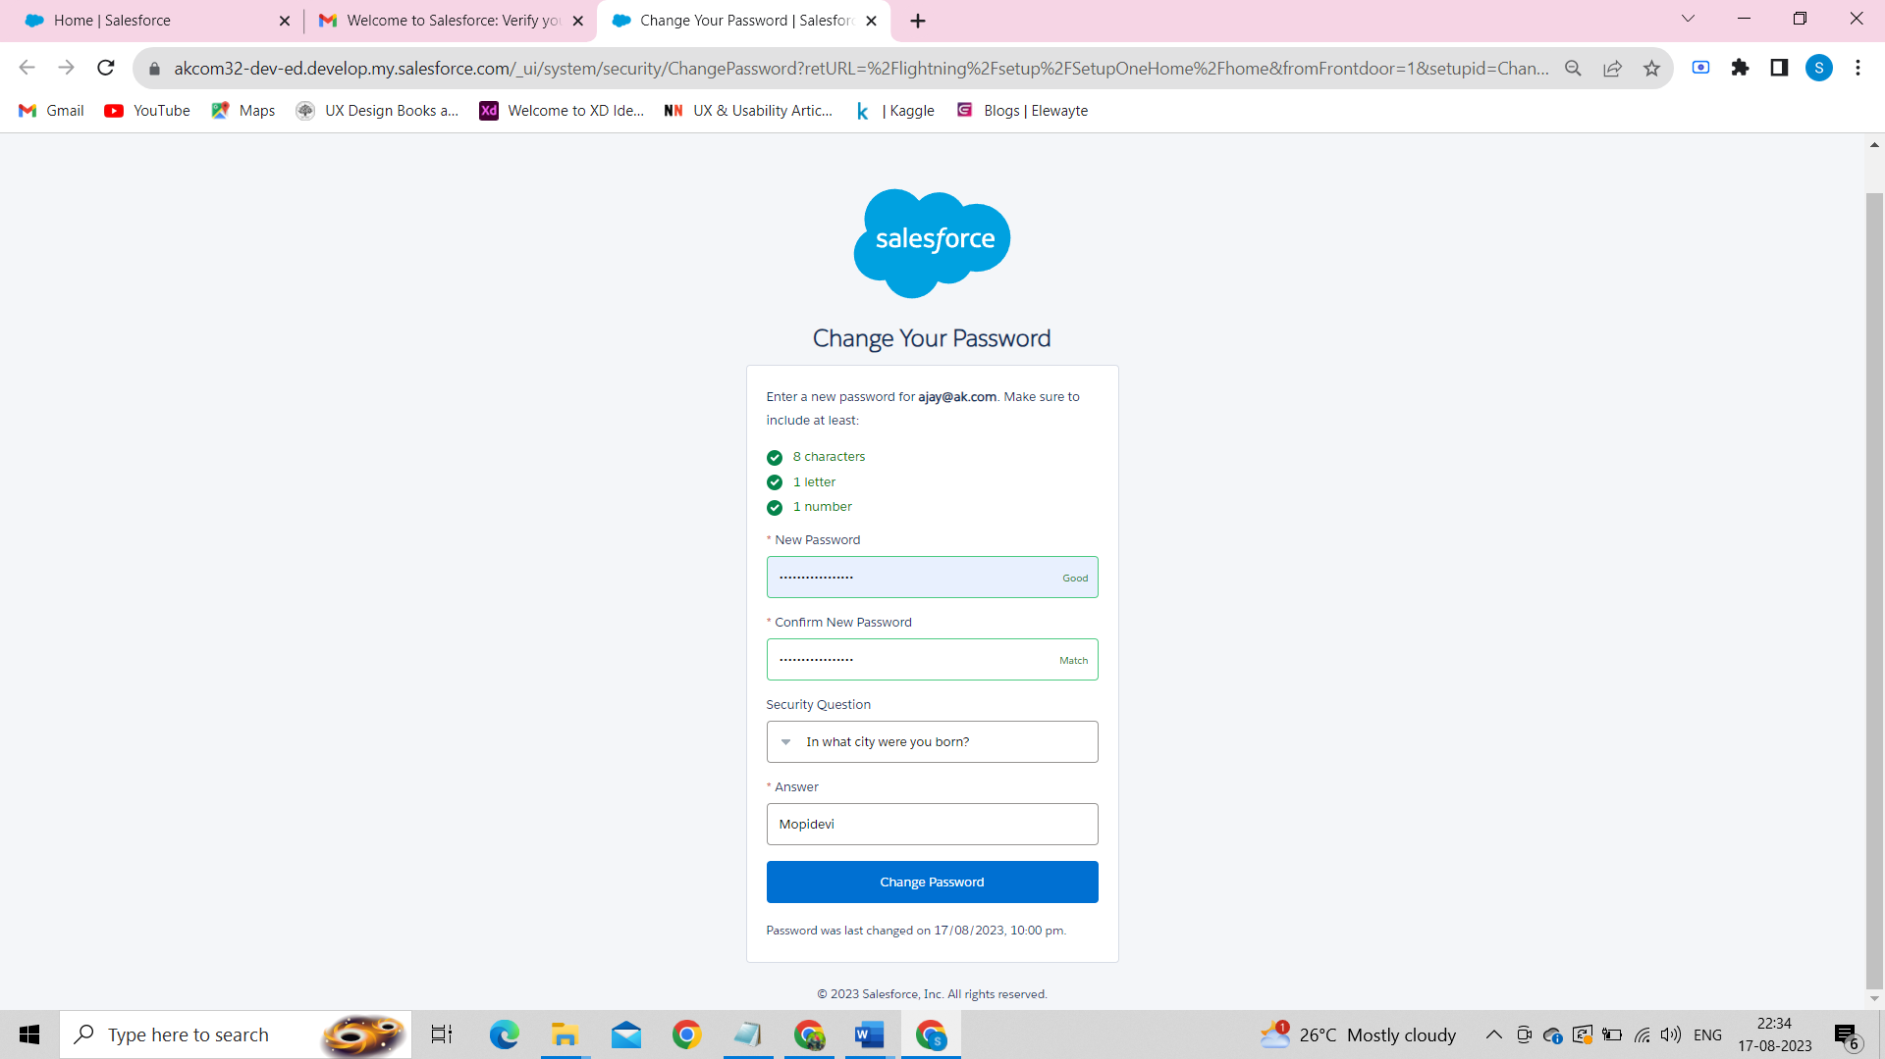

After setting the password, the page redirects to the Salesforce Setup Page where we are going to do each and every step regarding our project. It looks like this.

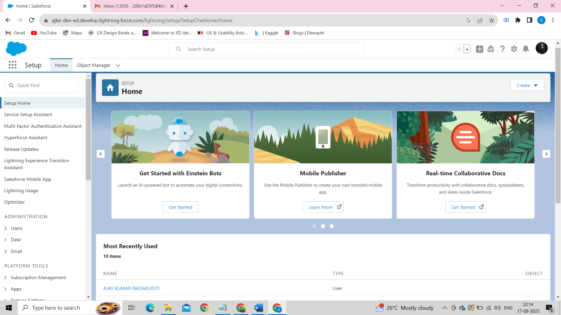

Here's a brief introduction to the key components of the Salesforce setup page:

1.Home: The central hub for Salesforce administrators to access and manage all setup options.

2.Object Manager: Customize and manage standard and custom objects, defining data structure and relationships.

3.App Launcher: Easily switch between Salesforce apps and custom-built applications.

**3.OBJECT :**

Salesforce objects are database tables that permit you to store data that is specific to an organization. Salesforce objects are of two types:

* Standard Objects: Standard objects are the kind of objects that are provided by salesforce.com such as users, contracts, reports, dashboards, etc.
* Custom Objects: Custom objects are those objects that are created by users. They supply information that is unique and essential to their organization. They are the heart of any application and provide a structure for sharing data.

**Coming to our project we have to create three custom objects:**

1.School Object

2.Student Object

3.Parent Object

Goto Object Manager and select Custom Object New and Create three objects First Object – School

* 1. Label: School
  2. Plural Label: Schools
  3. Record Name: School Name
  4. Check the Allow Reports checkbox
  5. Check the Allow Search checkbox
  6. Click Save.

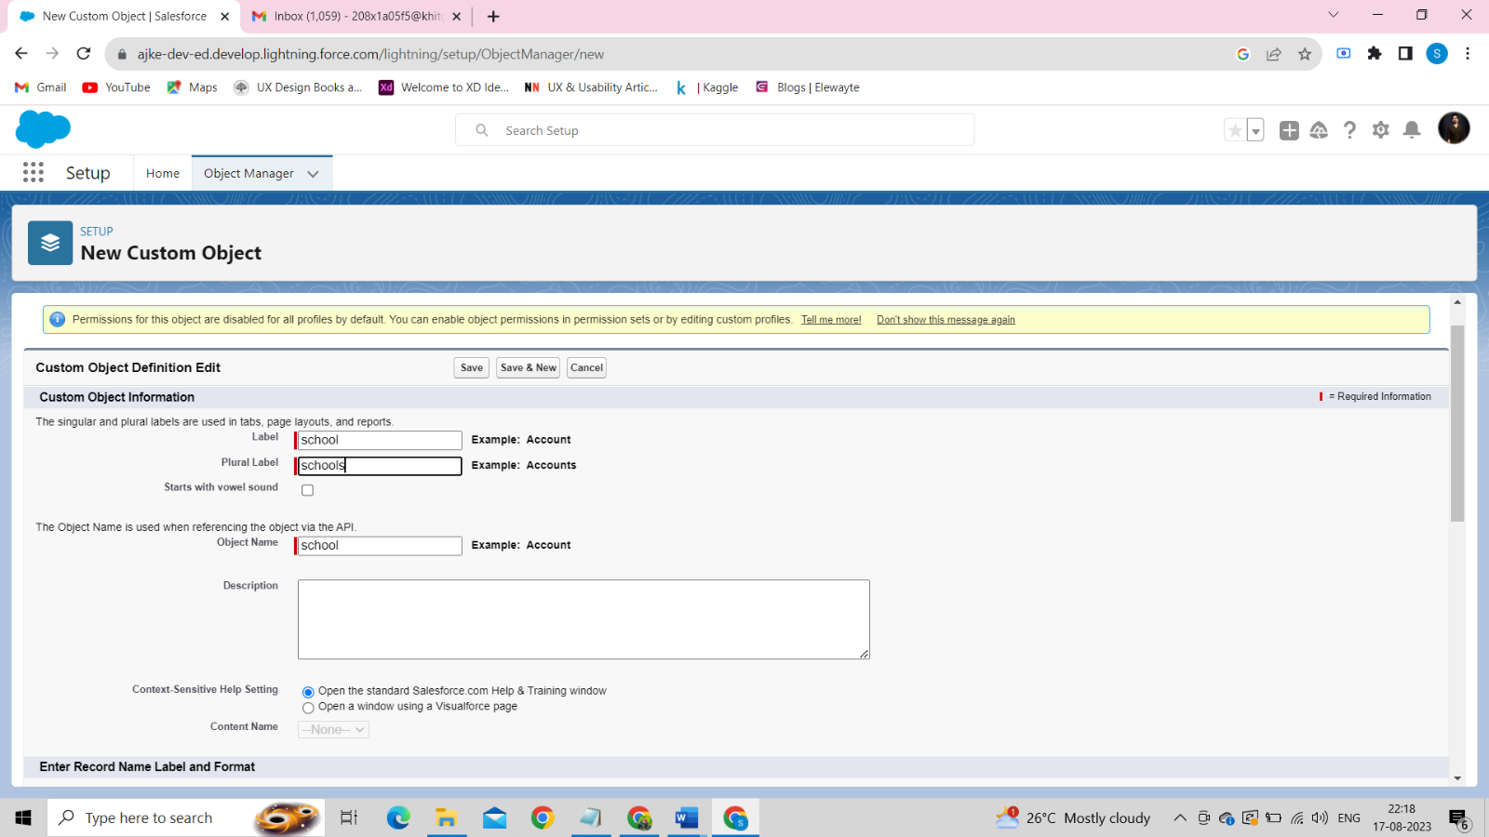

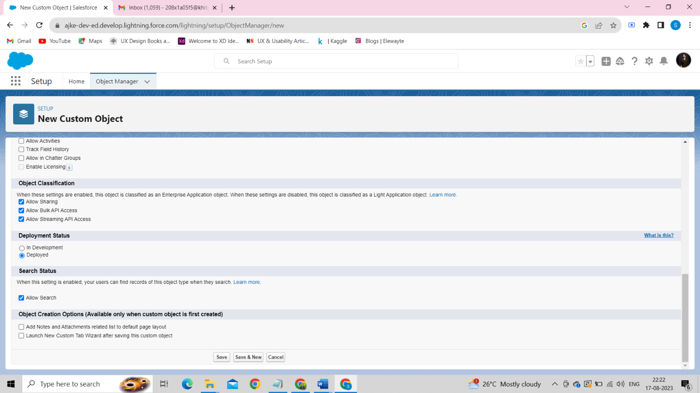

Now create a custom tab. Click the Home tab.

Search for Tabs Then Click it -→ Custom Tab→ New

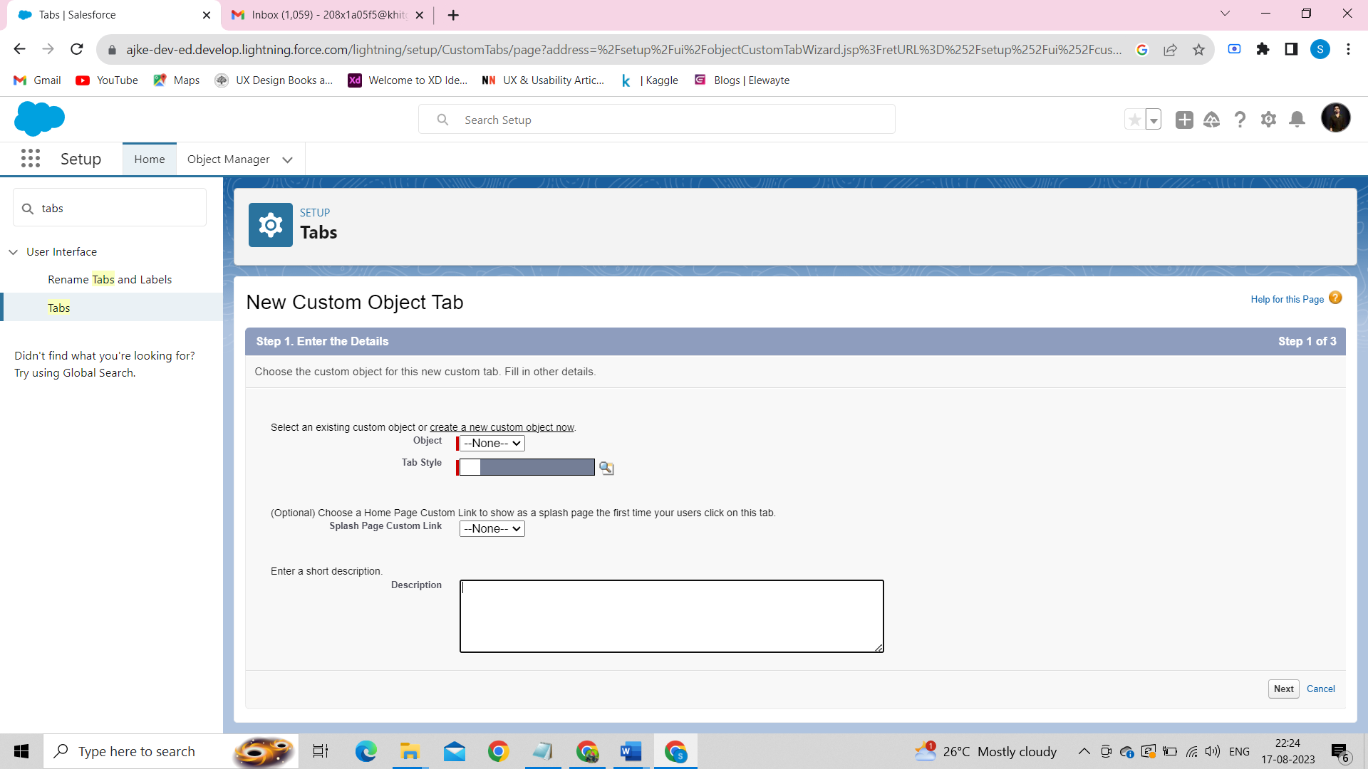

Select Object as School. And any Tab style. Click Next, Next and then Save. It looks like this.

In the same way, we created the two Custom objects like Student Object and Parent Object and their respective tabs as below:

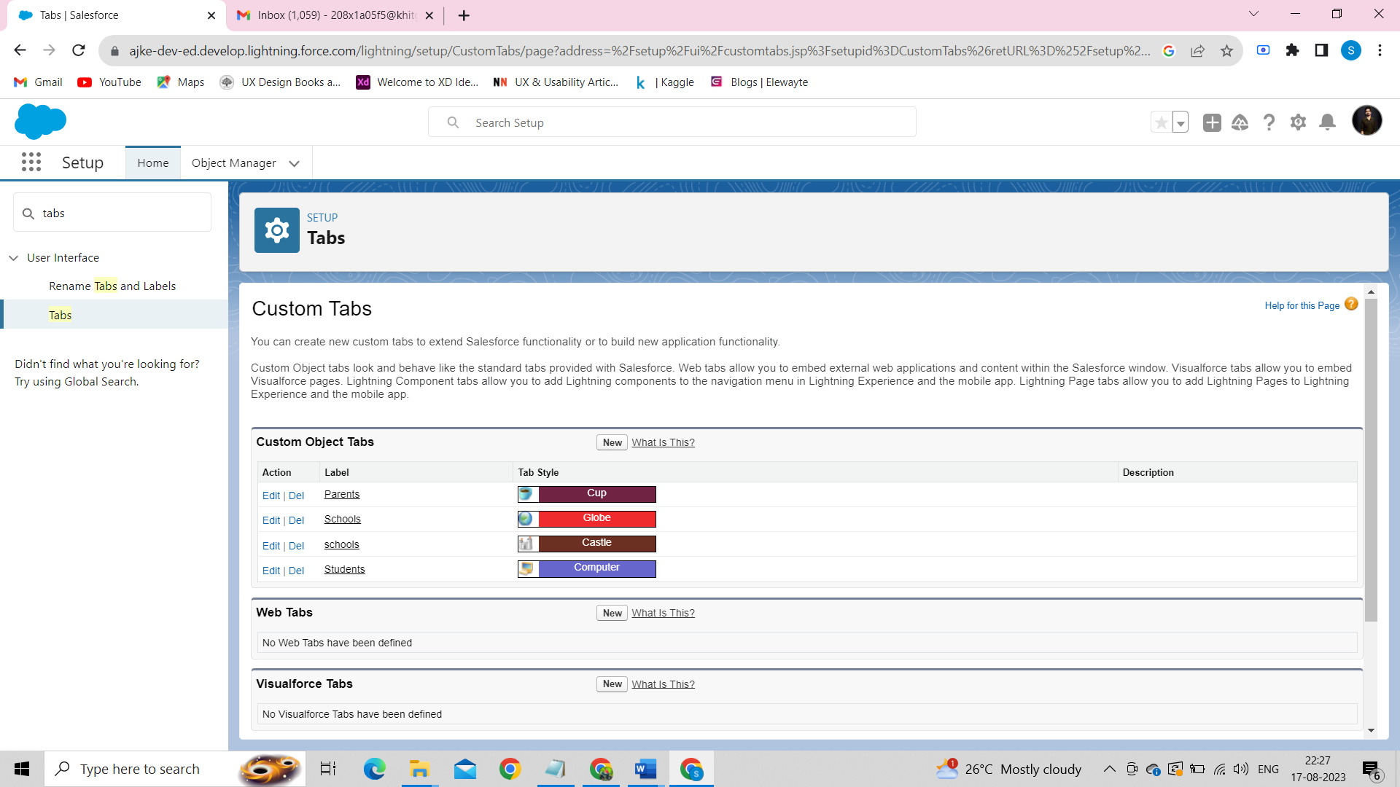

**4.Creating the Lightning App:**

Apps in Salesforce are a group of tabs that help the application function by working together as a unit. It has a name, a logo, and a particular set of tabs. The simplest app usually has just two tabs.

There are two types of app -

***1.Standard App***:

Standard apps come with every occurrence of Salesforce as default. Many features like Sales, Marketing, Community, call center, content, Salesforce Chatter, App Launcher, etc are present in it.

***2.Custom Apps***:

Custom apps are created according to need of user. Custom Apps are made by using standard and custom tabs together

1. From Setup, enter App Manager in the Quick Find and select App Manager.
2. Click New Lightning App.
3. Enter School Management as the App Name, then click Next 4. Under App Options, leave the default selections and click Next.
4. Under Utility Items, leave as is and click Next.
5. From Available Items, select Schools, Students, Parents, Reports, and Dashboards and move them to Selected Items. Click Next.
6. From Available Profiles, select System Administrator and move it to Selected Profiles. Click Save & Finish.

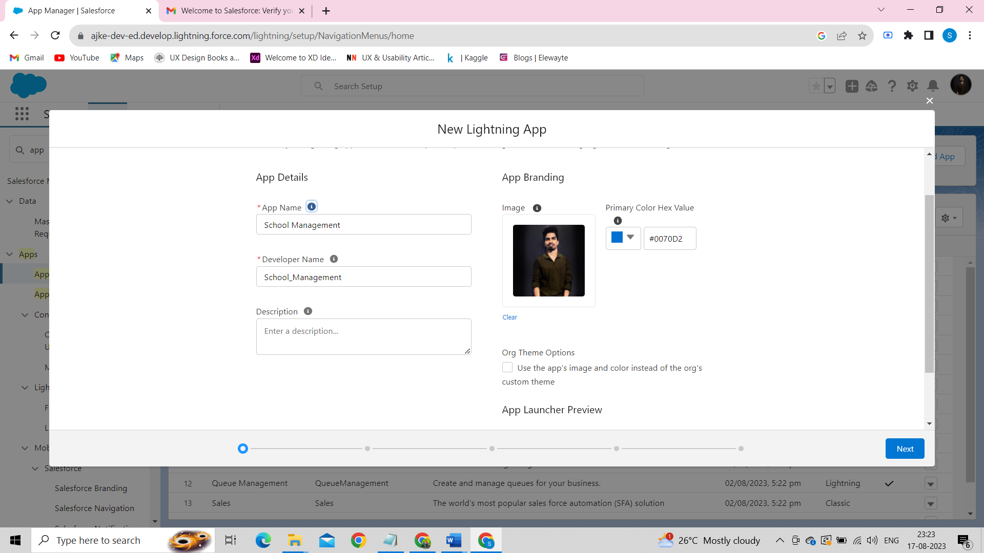

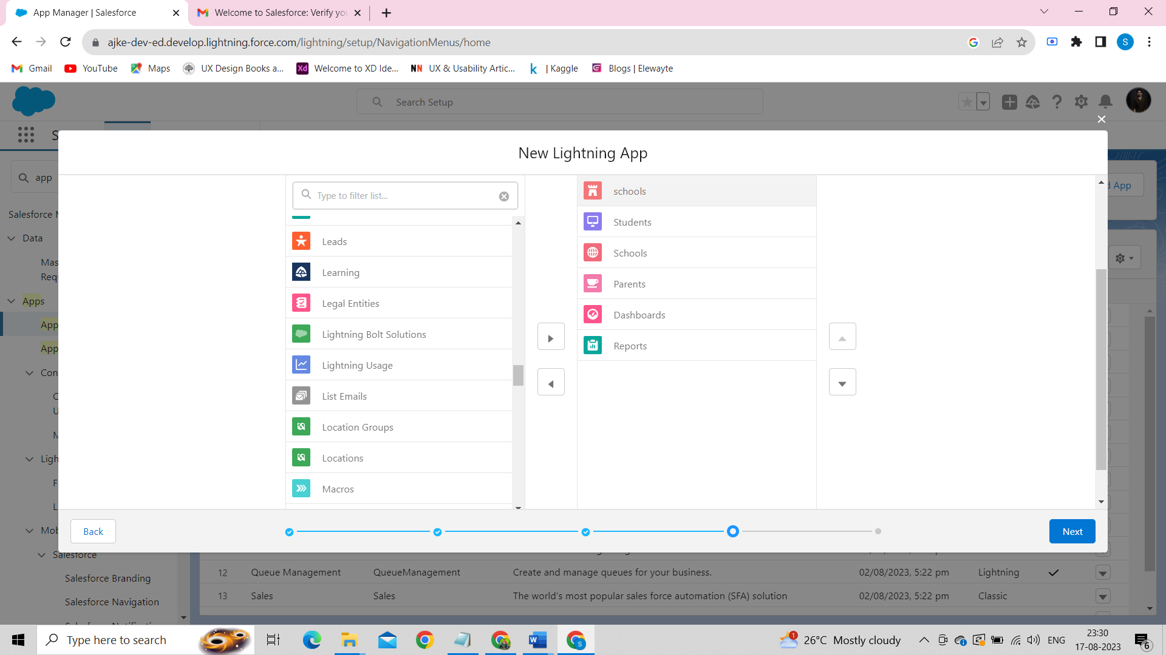

If we want to check the app we have created. Goto App Launcher → Search for the School Management App → Click it. The App looks like this.

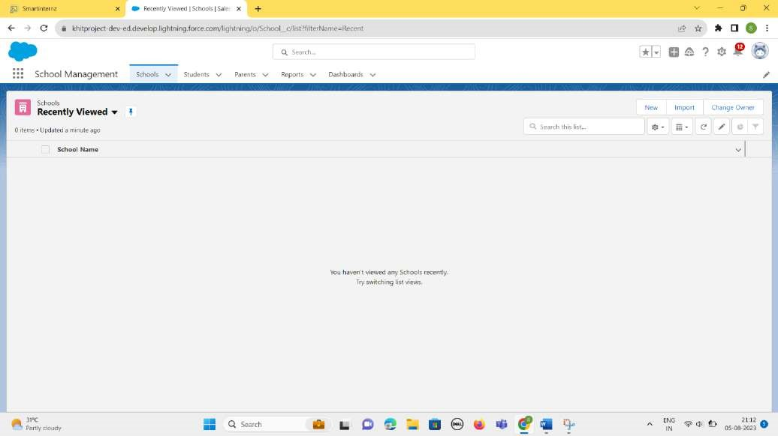

**5.Fields and Relationship :**

An object relationship in Salesforce is a two-way association between two objects. Relationships are created by creating custom relationship fields on an object. This is done so that when users view records, they can also see and access related data.

***Creation Of Fields for The School Object****:*

* 1. Click the gear icon and select Setup. This launches Setup in a new tab.
  2. Click the Object Manager tab next to Home.
  3. Select School.
  4. Select Fields & Relationships from the left navigation.
  5. Click New .
  6. Select the Text Area as the Data Type, click Next.
  7. For Field Label, enter Address.
  8. Click Next, Next, then Save & New.
  9. Follow steps 1 to 3 and create two more Text type field - District & State.
  10. Create URL type field & give School website as the field label.

We have to create 5 fields for the School Object. They are – *Address, District, State*, *Phone, URL* with their respective Relationships.

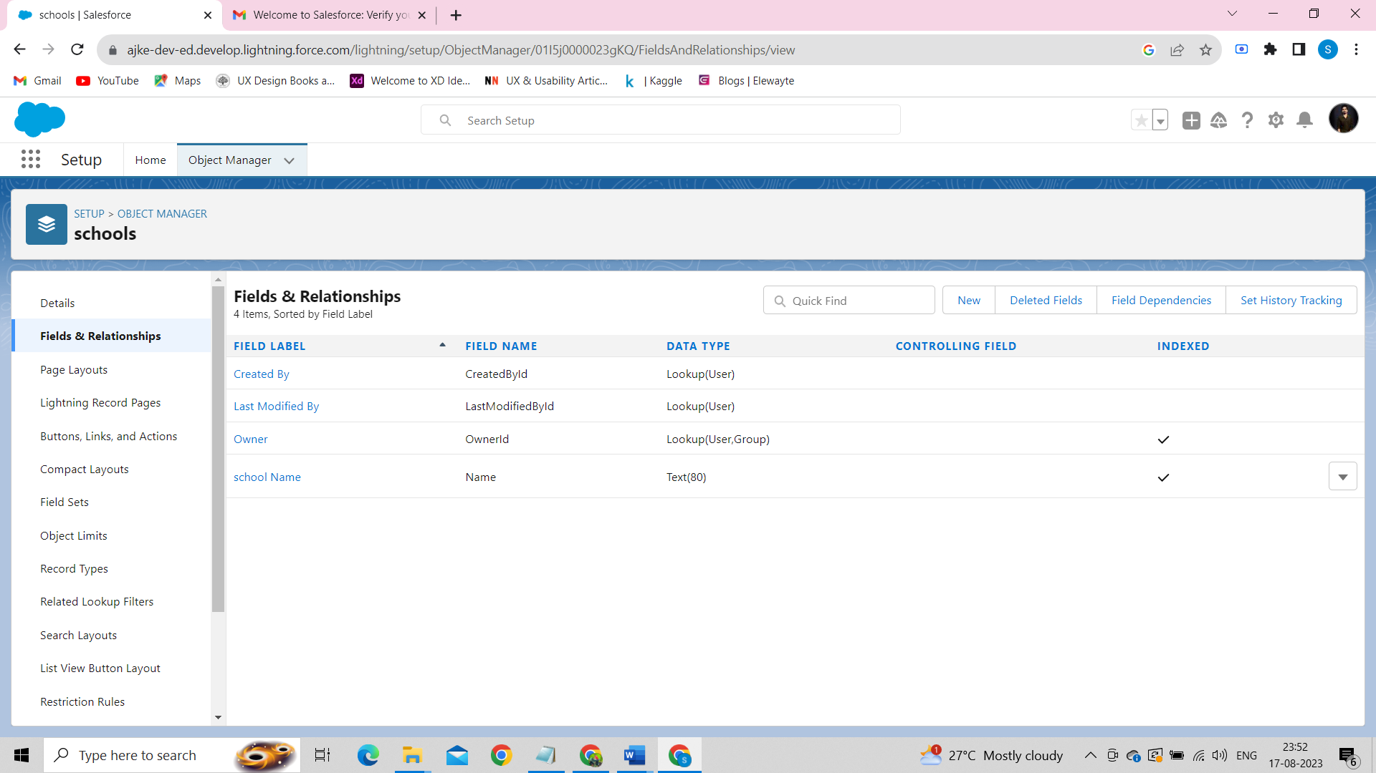

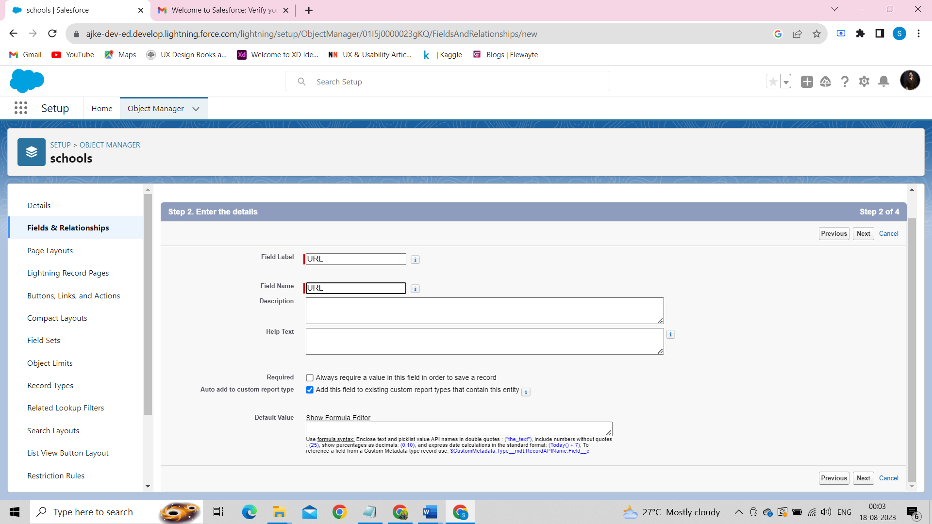

After creating all the required fields for the School Object

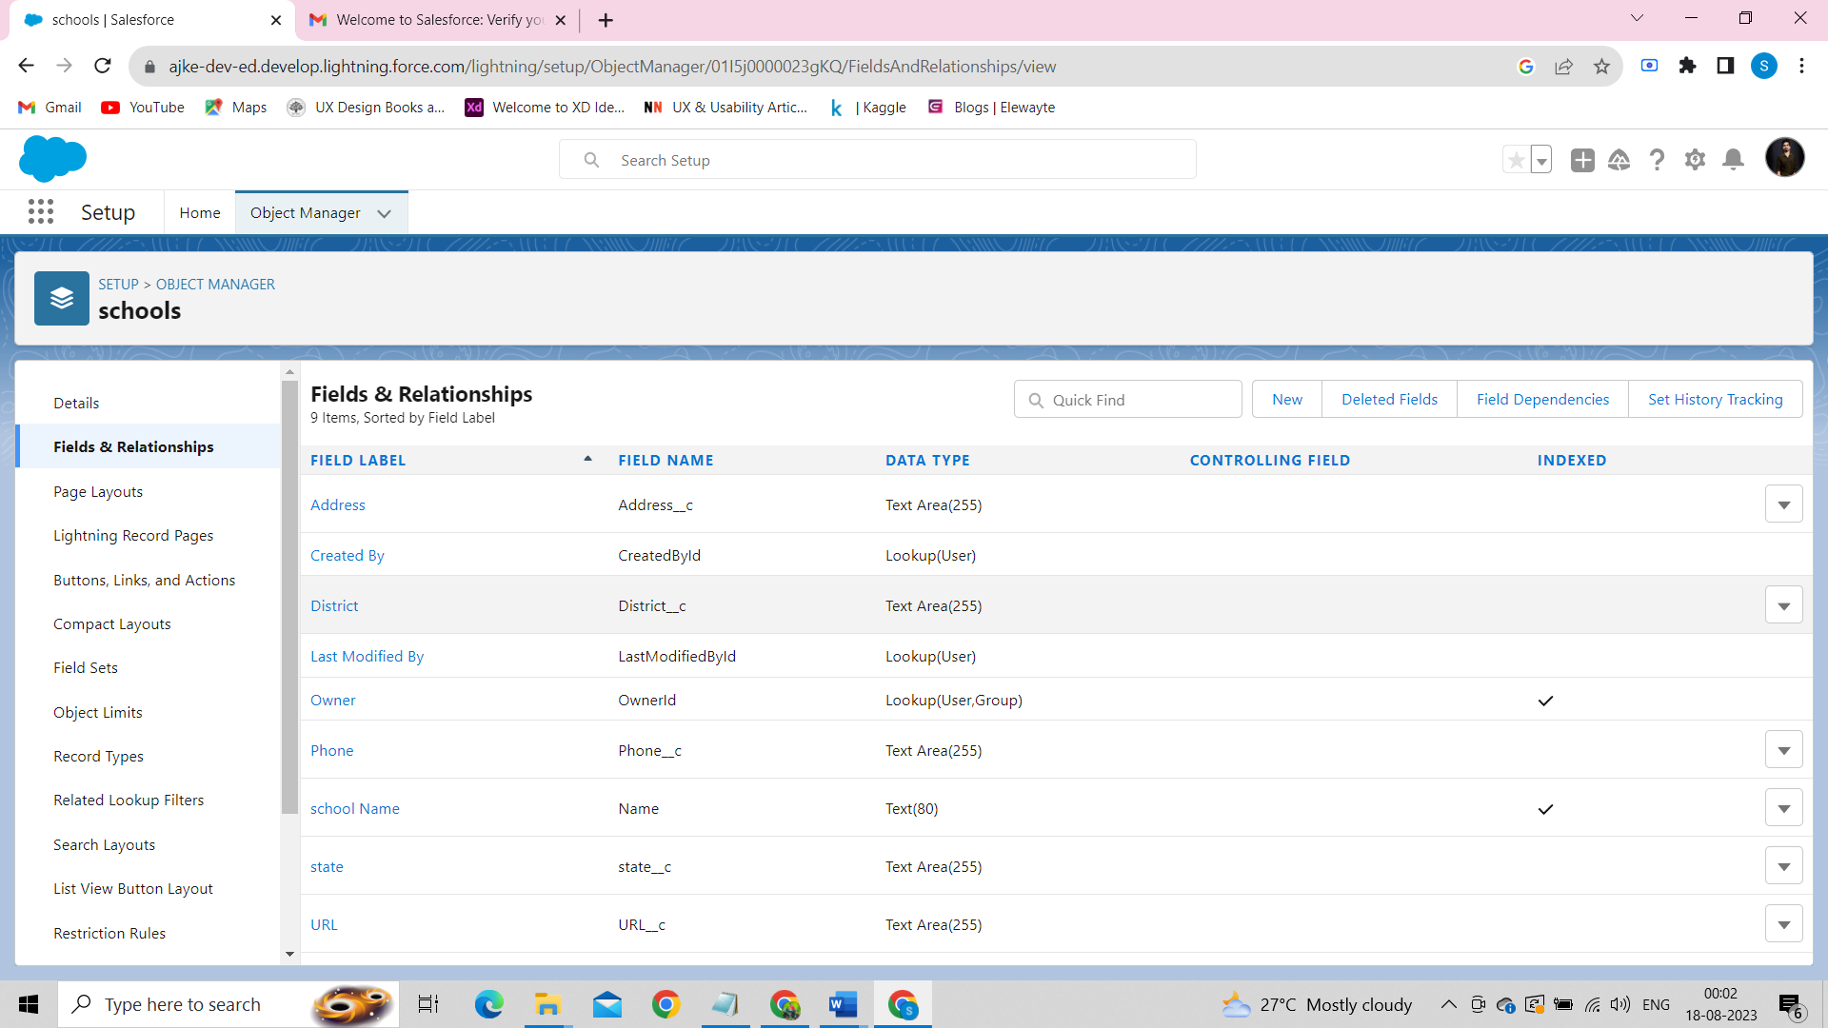

***Creation Of Fields for The Student Objects*:**

Field 1: – *Results* and Relationship is of Picklist type and we have to enter the picklist values as Pass, Fail.

Field 2:- *Class* and Relationship is of Number type.

Field 3:- *Marks* and Relationship is of Number type.

Field 4:- *Number of Students* and Relationship is of Roll-up Summary type

After creating the required above fields looks like this ..

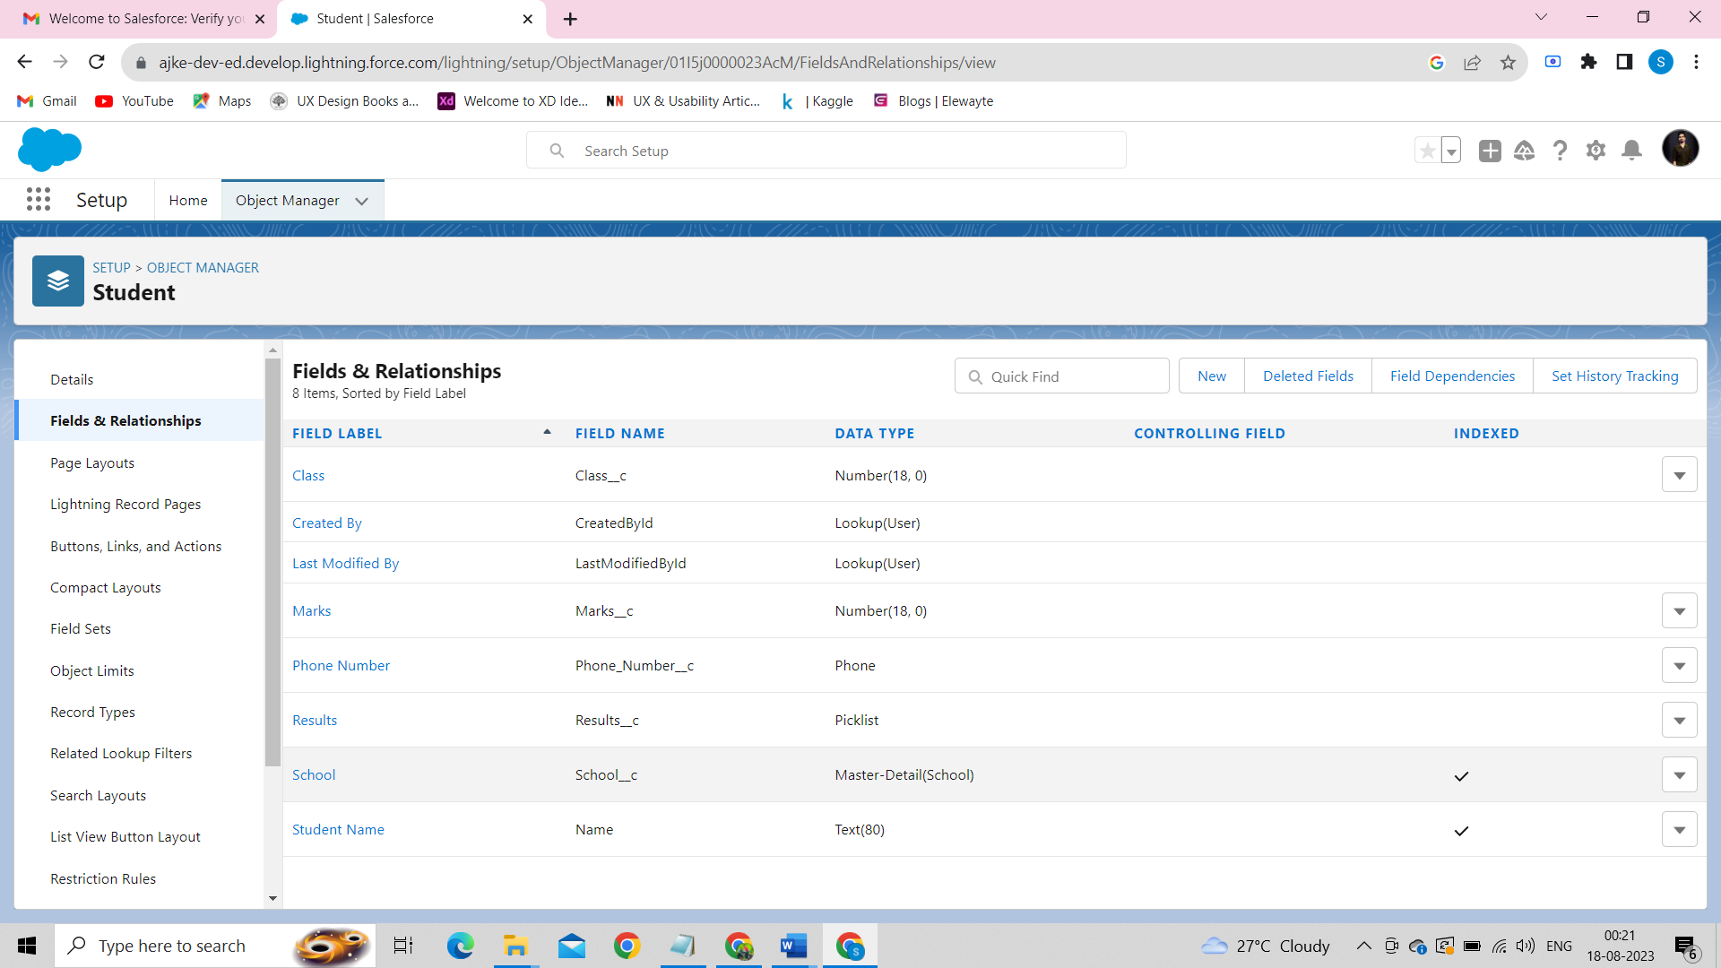

***Creation Of Fields for The Parent Objects:***

We have to create 2 fields :

Field1 :– *Parent Address* and relationship is of Text area

Field2 :- *Parent Number* and relationship is of Phone.

After creating the above two fields, it looks like this:

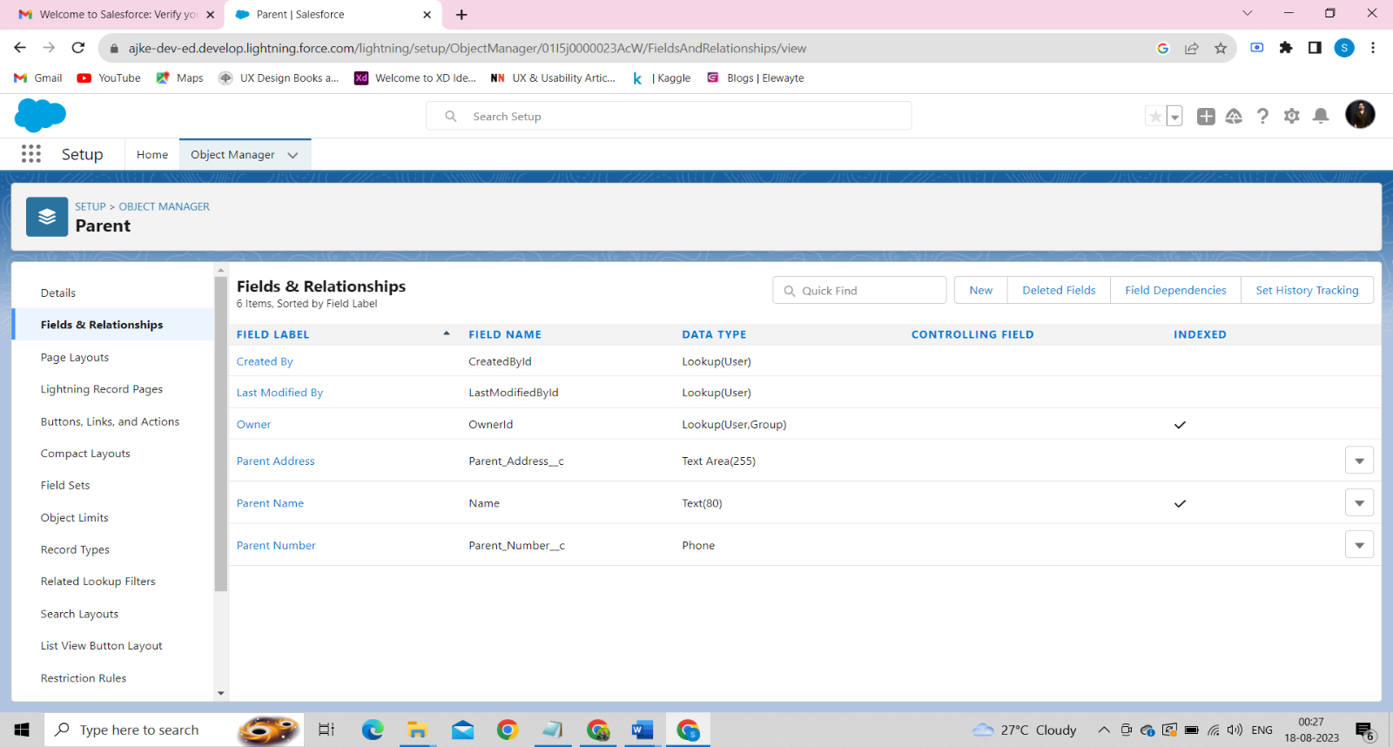

**6.Profile :**

A profile is a group/collection of settings and permissions that define what a user can do in salesforce. A profile controls “Object permissions, Field permissions, User permissions, Tab settings, App settings, Apex class access, Visualforce page access, Page layouts, Record Types, Login hours & Login IP ranges.

***Creation On Profile:***

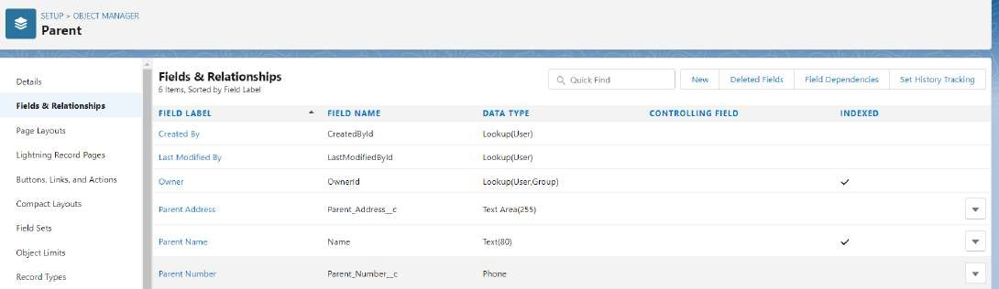1.From Setup enter Profiles in the Quick Find box

2.Select Profiles.

3.Click new, From the list of profiles, find Standard User (profile to clone)

4.For Profile Name, enter School Profile

5.Click Save.

6.While still on the School Profile page, then click Edit.

7.Scroll down to Custom Object Permissions and Give view all access permissions.

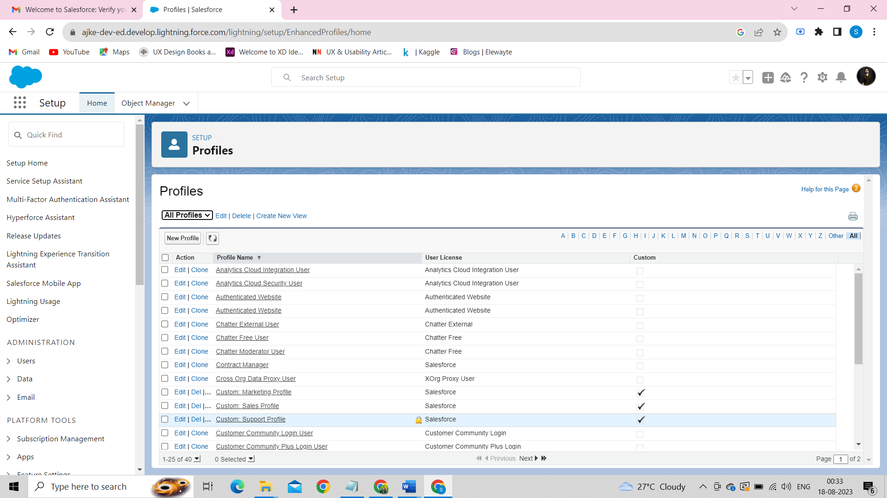

The “School Profile” is created as below:

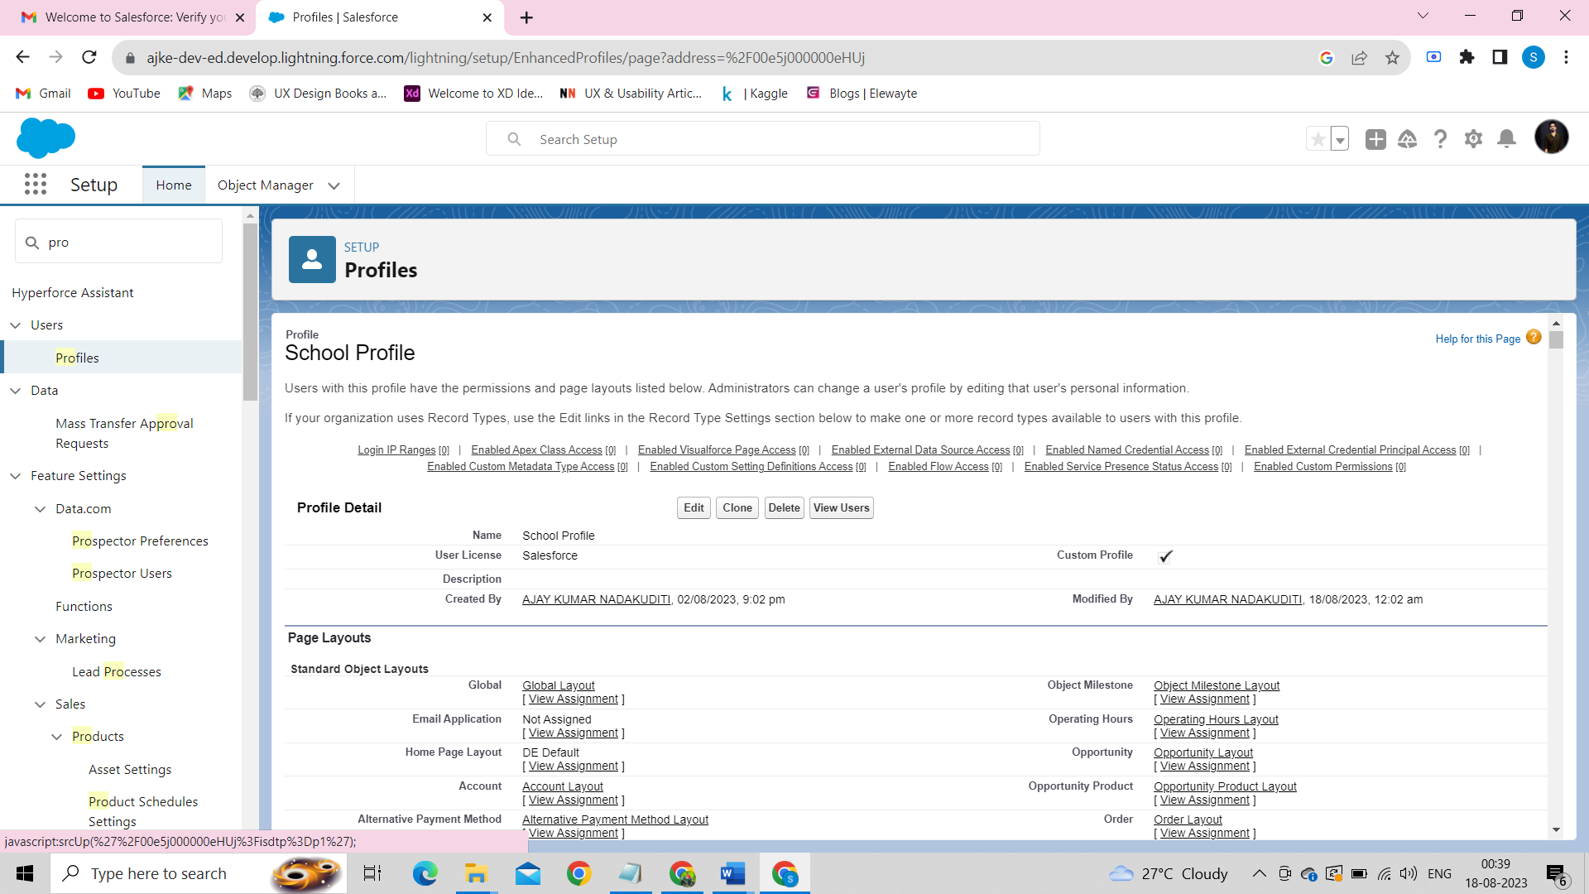

**7.Users:**

A user is anyone who logs in to Salesforce. Users are employees at your company, such as sales reps, managers, and IT specialists, who need access to the company's records. Every user in Salesforce has a user account.

Creating A User:

1.From Setup, in the Quick Find box, enter Users.

2.Select Users.

1. Click New User.
2. Enter the user’s name Parents and (Your) email address and a unique username in the form of an email address. By default, the username is the same as the email address.
3. Select a User License as salesforce.

NOTE- As Salesforce license can only be used by 2 Users at a time in Dev Org, so If you don’t find salesforce license then deactivate a user who has salesforce license or change the license type from Salesforce to any other.

6.Select a profile as a School Profile.

1. Check Generate new password and notify the user immediately to have the user’s login name and a temporary password emailed to your email.
2. Similarly follow the above steps and create 2 users as Teachers and principals.

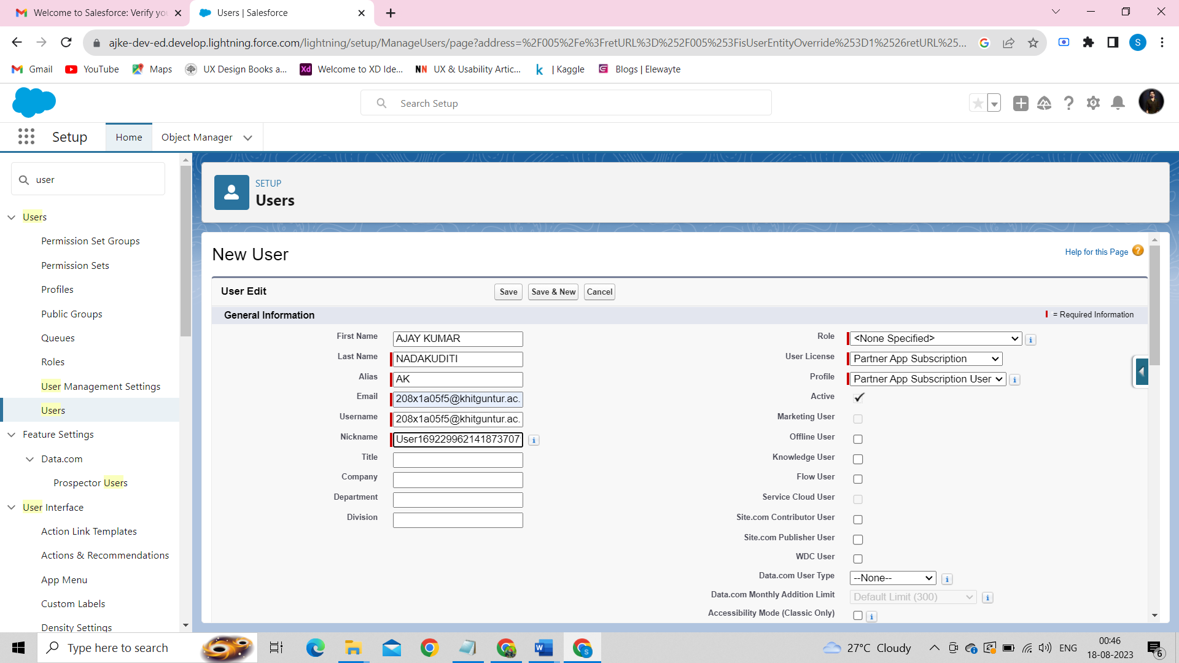

Similarly, we created two users -Teachers and Principals like below:

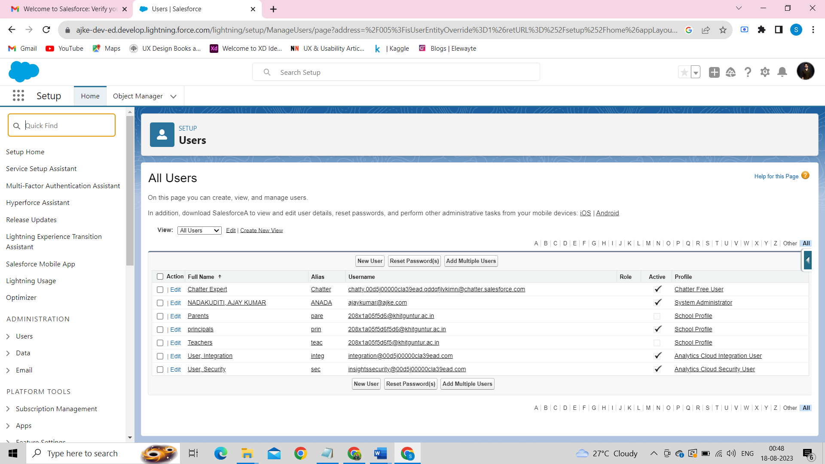

### **8.Permission Sets:**

A permission set is a collection of settings and permissions that give users access to various tools and functions. Permission sets extend users' functional access without changing their profiles.

***Permission Sets 1:-***

1.From Setup, enter Permission Sets in the Quick Find box, then select Permission Sets.

2.Click New.

3.Give the name of the Permission set name as teacher permission.

4.Under the object settings give the view create and edit permissions to all 3 custom objects (By click open the object)

5.Click on manage assignment

6.Click on add assignment.

7.Click on Teacher (user), Next, Assign.

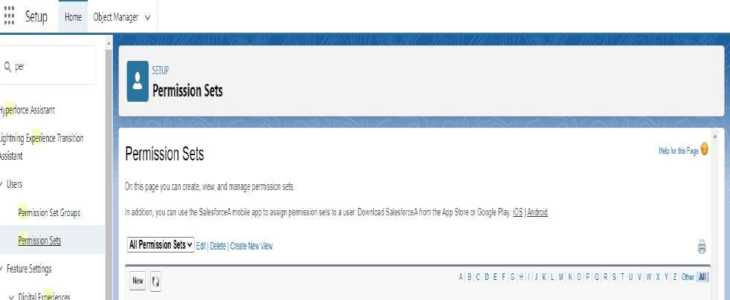

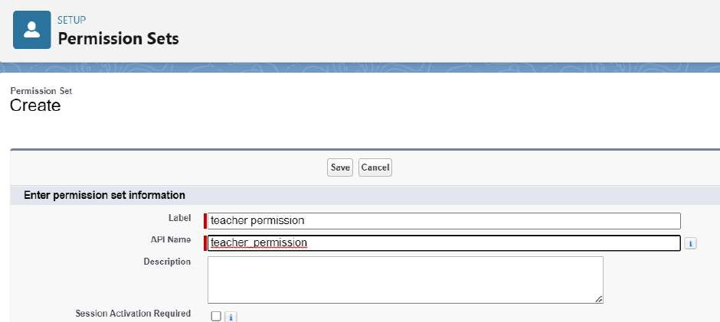

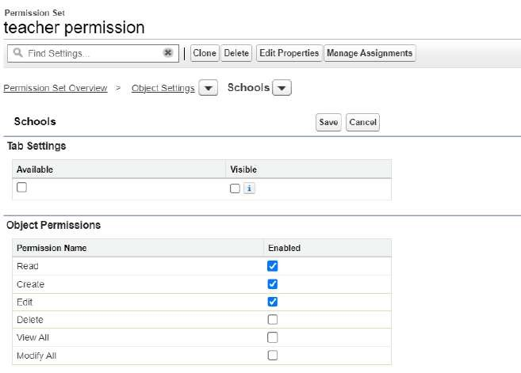

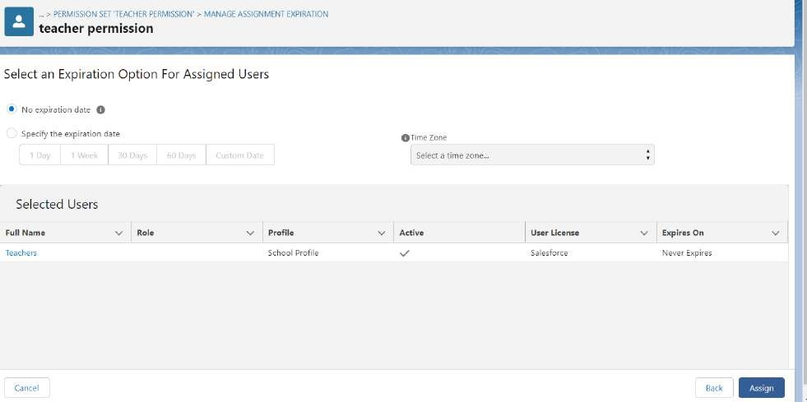

**Permission Sets 2:**

Similarly, we create another permission set that is Principal permission.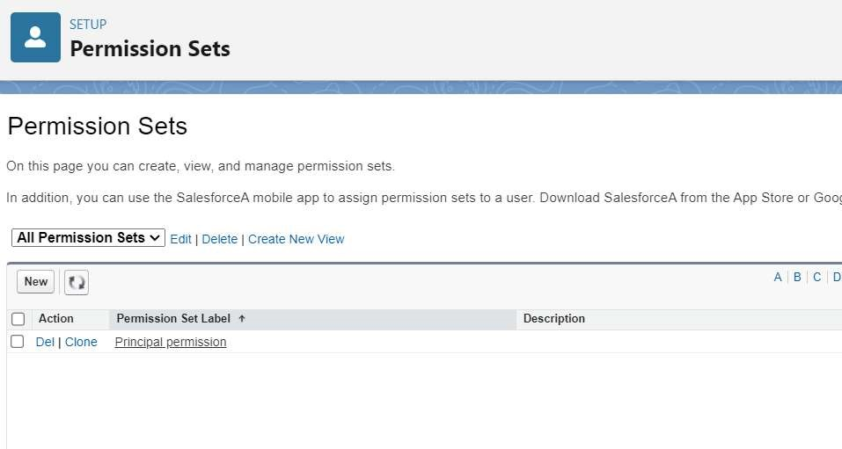

### **9.User Adoption :**

***Create Record (School):***

1.Click on App Launcher on left side of screen.

2.Search School Management App & click on it.

3.Click on Schools tab.

4.Click new button

5.Fill all School record details.

6.Click on Save Button

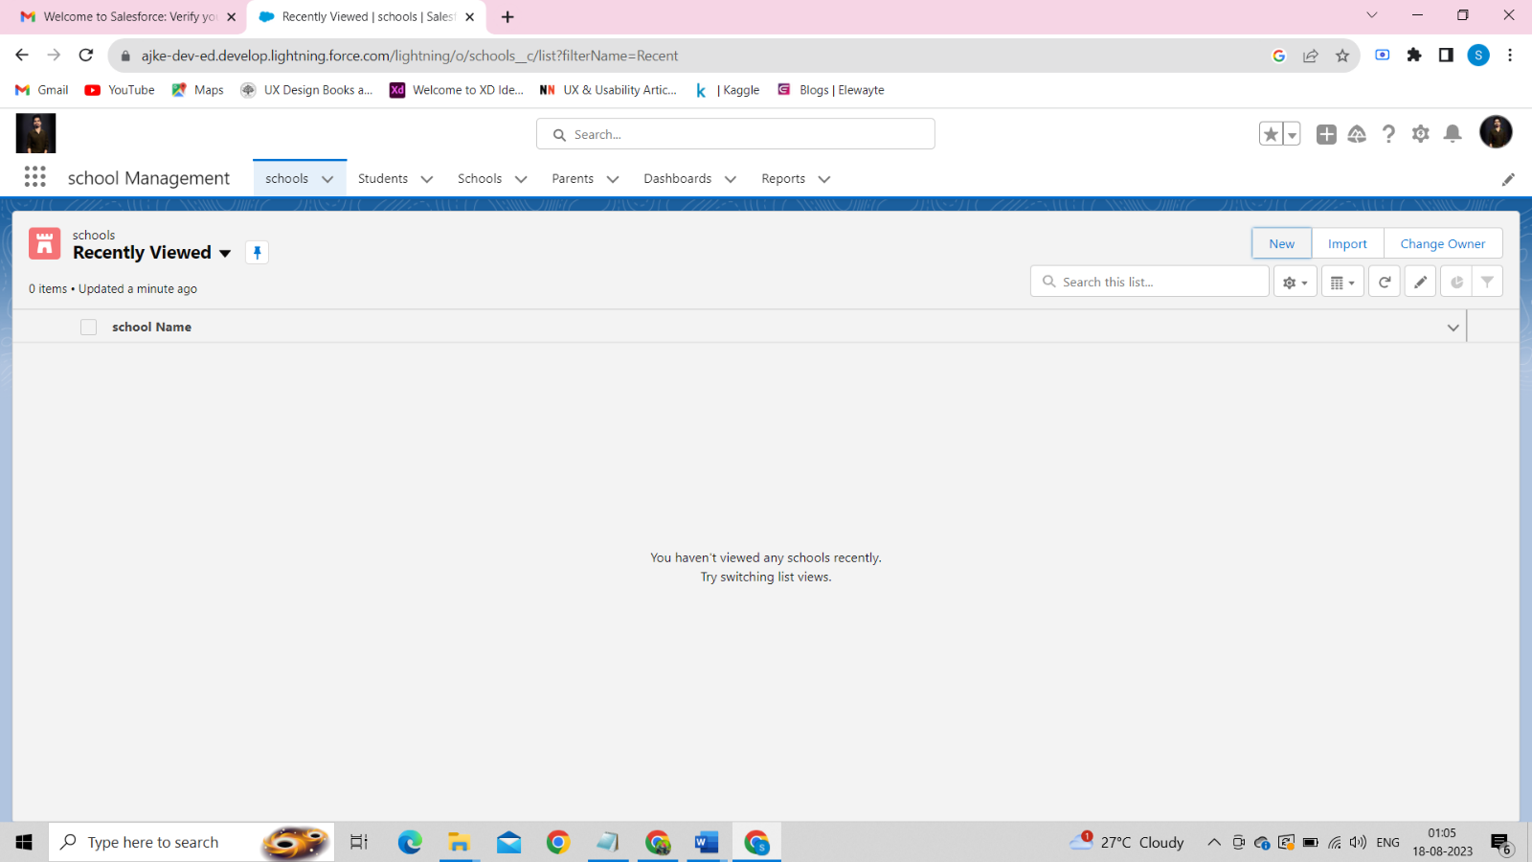

Clicking new, we have to fill the details of the school like School Name, Address, State, District, Phone Number, School Website.

This is displayed below:

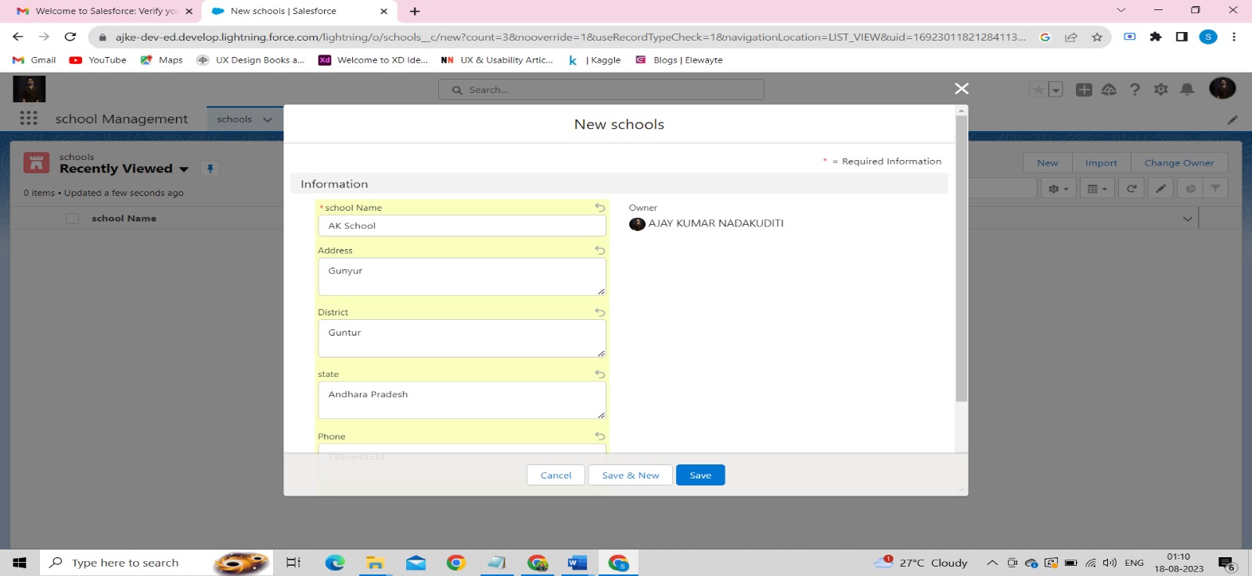

View Record (School):

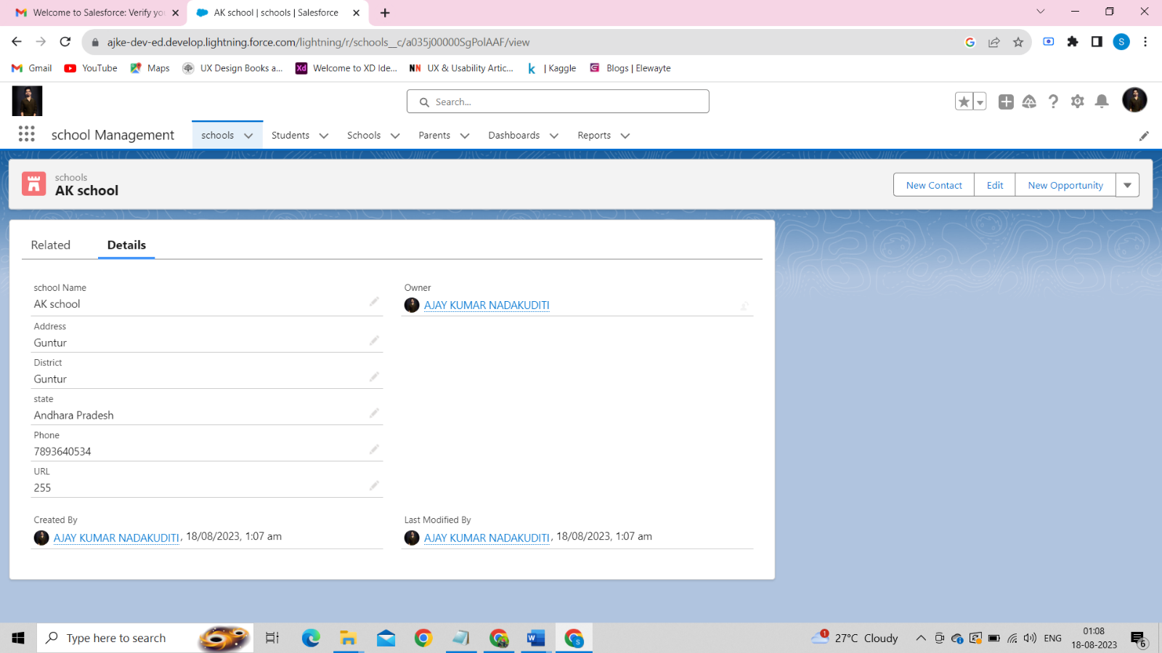

Delete Record (School):

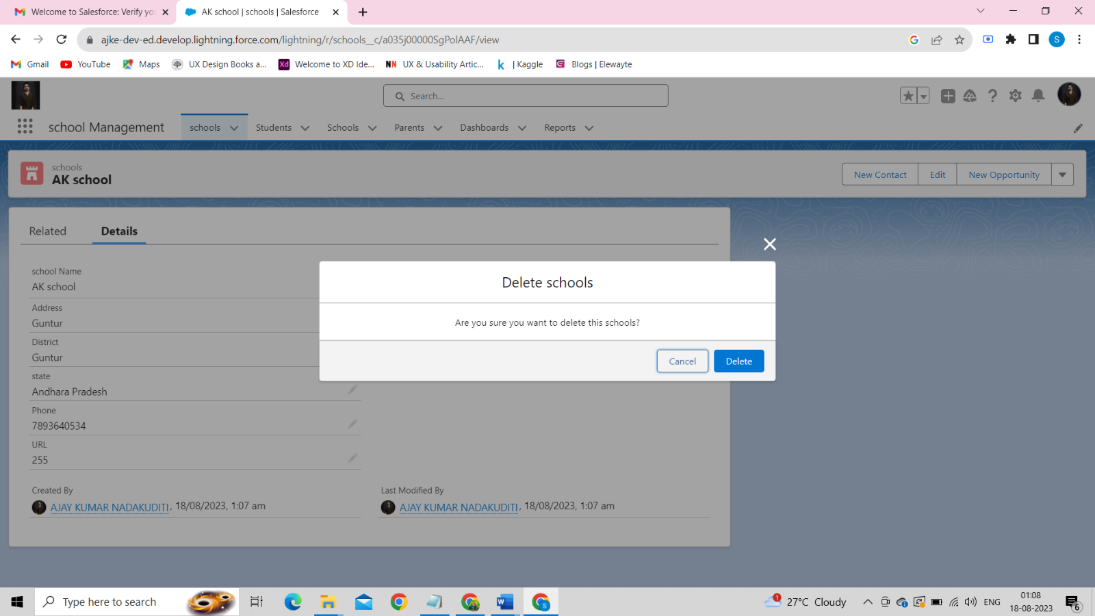By Clicking it, The School named “*Shalome English Medium School* “ will be deleted . And it is not Visible. 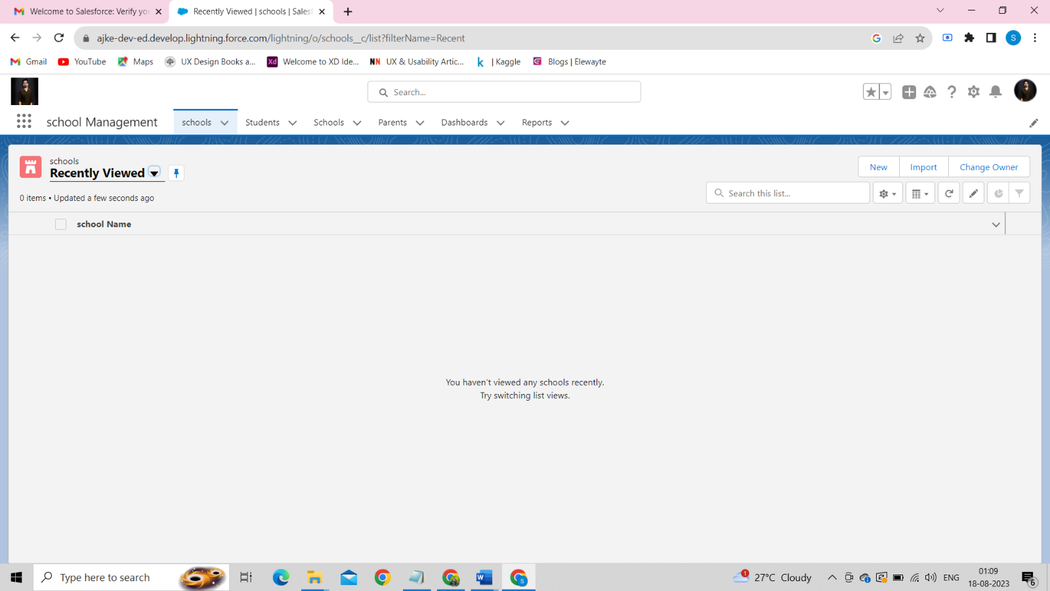

## **10.Reports :**

Reports in Salesforce is a list of records that meet a particular criterion which gives an answer to a particular question. These records are displayed as a table that can be filtered or grouped based on reports.

Create Report:

1.In School Management App click Reports tab.

2.Click New Report.

3.Select the report type as School with students and parents for the report.

4.Click start report.

5.Customize your report, then save and run

6.Give report name – Schools with Students Report

7.Click Save.

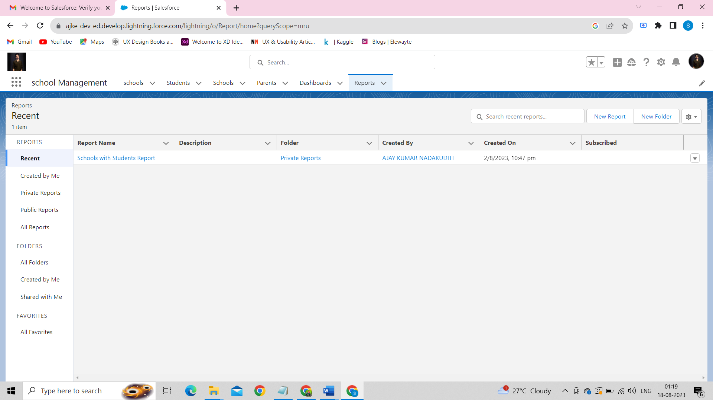

***The following is the format of the Report for the school:***

* It contains *Outlines* and *Filters*
* In Outlines tab we have- Group Rows, Group Columns.
* In the Columns Tab, we have Columns like *School: School Name*, *Student: Student Name*
* Now we have to save the report with the Report Name – “*Schools with Students Report”.* Click save & run at the top and save it as below:

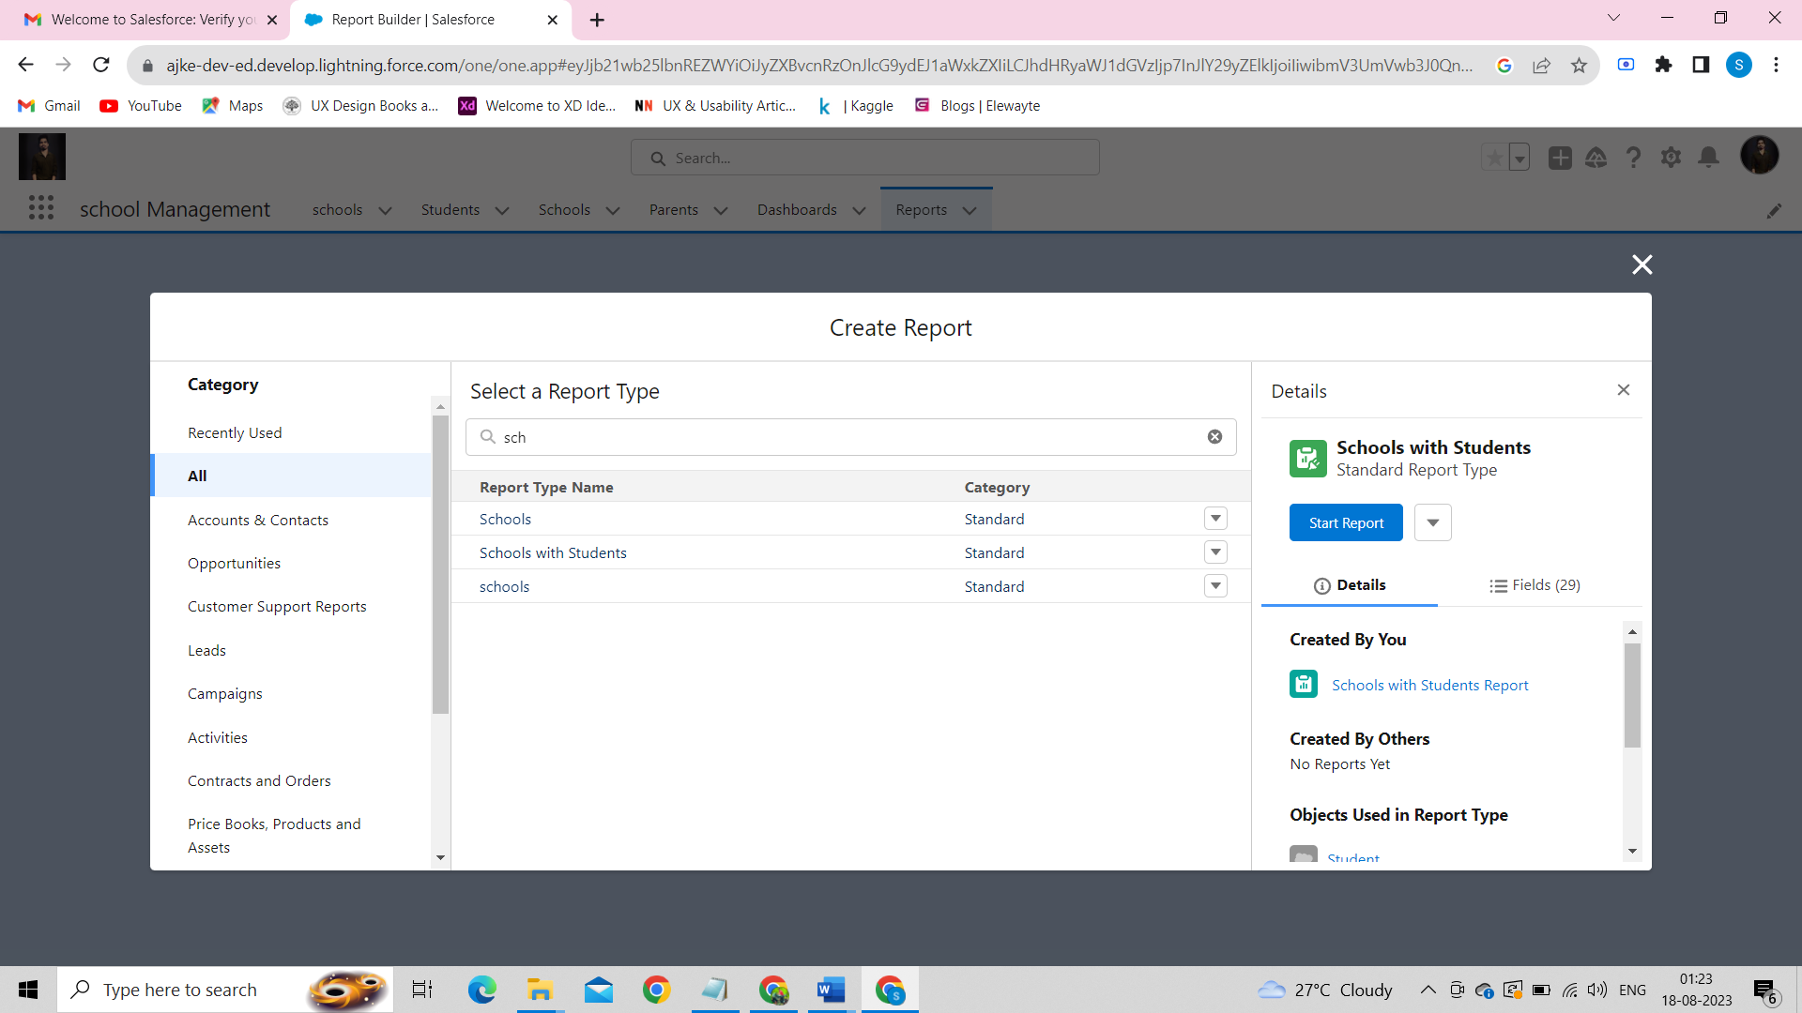

View Report:

1.Click on App Launcher on left side of screen.

2.Search School Management App & click on it.

3.Click on Reports Tab.

4.Click on School with Students report and see records

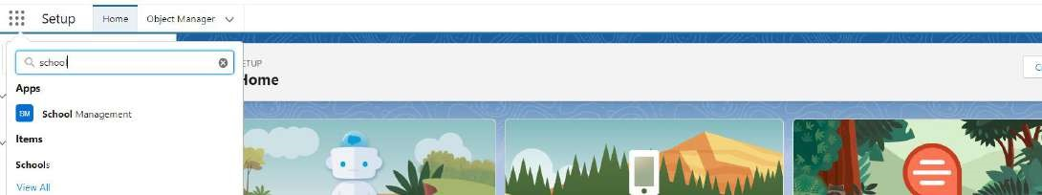

In this way, we have successfully created the *School Management App* and performed all the actions.

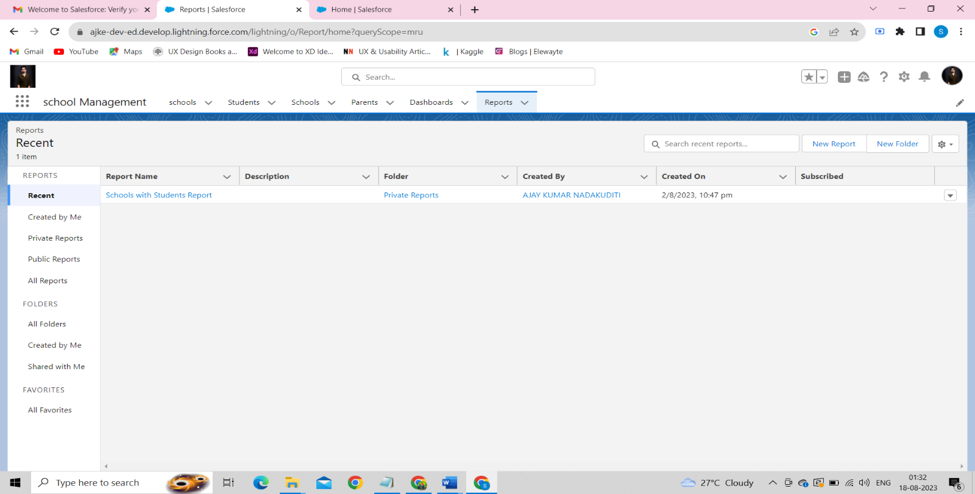

### **ADVANTAGES & DISADVANTAGES**

**Advantages:-**

* based: Salesforce is a cloud-based platform, which means that it is accessible from Cloud anywhere with an internet connection. This makes it a convenient and flexible solution for schools of all sizes.
* Integrated ecosystem: Salesforce has a wide range of integrated applications that can be used to extend the functionality of the school management application. This can help to save schools time and money by eliminating the need to use multiple systems.
* Customizability: Salesforce is highly customizable, which means that it can be tailored to the specific needs of each school. This can help to ensure that the application is used effectively and efficiently.
* User-friendly interface: Salesforce has a user-friendly interface that is easy to use for both administrators and end users. This can help to reduce the learning curve and make it easier for users to get started with the application.
* Security and compliance: Salesforce is committed to security and compliance. The platform has a number of security features in place to protect student data, and it meets all applicable data privacy regulations.

**Disadvantages:-**

* Cost: Salesforce can be expensive, especially for small schools. However, the cost of Salesforce can be offset by the benefits that it offers, such as increased efficiency and productivity.
* Learning curve: Salesforce has a steep learning curve, which can make it difficult for new users to get started with the platform. However, there are a number of resources available to help users learn Salesforce, such as online tutorials and documentation
* Dependency on Salesforce: Salesforce is a proprietary platform, which means that schools are dependent on Salesforce for support and updates. If Salesforce were to go out of business or experience a major outage, it could impact the school's ability to use the platform.
* API limitations: Salesforce imposes limits on the number of API calls that can be made each month. This can be a challenge for schools that need to integrate Salesforce with other systems.
* Data ownership: Salesforce owns the data that is stored in its platform. This means that schools do not have full control over their data.
* Offline access: Salesforce is not a fully offline solution. This means that schools need to have an internet connection in order to access the platform.
* Limited customization in Low-Code Solutions: Low-code solutions offer limited customization capabilities. This can be a challenge for schools that need to customize the application to meet their specific needs.

**APPLICATIONS:**

The application can be used by a variety of educational institutions, including:

* Schools and K-12 institutions
* Colleges and universities
* Online learning platforms
* Tutoring centers and coaching institutes
* Non-profit educational initiatives
* Training and development programs
* Vocational institutes
* Special education programs
* After-school programs
* Language schools

The application has the potential to revolutionize the way schools are run. By automating administrative tasks and improving communication, the application can help schools to provide a better educational experience for their students.

In the future, the application could be extended to include new features and functionality, such as:

* A mobile app for teachers and parents.
* A data analytics dashboard for administrators.
* Integration with other educational systems, such as learning management systems and student information systems.

***CONCLUSION :***

*The proposed school management application has the potential to revolutioniz the way schools are run. By automating administrative tasks and improving communication, the application can help schools to save time and money, and to provide a better educational experience for their students*.

***FUTURE SCOPE :***

The School Management Application in Salesforce has a promising future scope, with several potential enhancements and improvements that can be implemented to further enhance its functionality and impact. Some future enhancements include

* The application can be made more accessible by making it available on mobile devices and by translating it into multiple languages.
* Artificial intelligence can be used to automate tasks and provide personalized recommendations to students.
* The application can be integrated with other systems, such as learning management systems and student information systems, to make it easier for students to learn and for teachers to manage their classes.
* The application can be used to collect data on student behavior and performance, which can then be used to improve teaching and learning.
* Gamification and rewards can be used to motivate students to learn and achieve their goals.
* Virtual reality and augmented reality can be used to create immersive learning experiences.
* Predictive analytics can be used to identify students who are at risk of failing and provide them with additional support.

These are just a few of the ways that the School Management Application in Salesforce can be enhanced to improve the education experience. As technology continues to evolve, we can expect to see even more innovative ways to use this application to improve the lives of students and teachers.

# Thank You….